**SUBMISSION TEMPLATE OF EXTENDED SUMMARY**

**Extended Summary must follow this format to be considered for the National Symposium on Coastal Agriculture (NSCA 2025). Submit completed Extended Summary online in the symposium website within January 15, 2025. Please make sure you have read the Submission Guidelines prior to submitting your summary.**

Papers of relevant topics within the symposium themes are invited for oral/poster presentations. Authors are requested to submit an extended summary not exceeding **two (A4 size) pages** and 1000 words in English. The extended summary must include the title, author(s), keywords, introduction, material and methods, results and discussion, conclusion, acknowledgement and references. The manuscript should be prepared on an A4-sized paper with 25 mm margins on all sides and typed with 1.5 spacing using size 11 Times New Roman font. All illustrations must be prepared inside of the main text. Only one figure and one table will be allowed in the extended summary.

Title of your Extended Summary (TNR Bold 14 pt Centered)

AUTHOR A1*, AUTHOR B2 and AUTHOR C3 (TNR 12pt centered) (Author name should be given as Initials of First and Middle names followed by Last name eg. M. K. SHARMA)

1Institution 1, City 1 – PIN code, State 1, Country 1 (TNR 12 pt centered)

2Institution 2, City 2 - PIN code, State 2, Country 2

3Institution 3, City 3 - PIN code, State 3, Country 3

*E-mail: (Corresponding/presenting author) (TNR 12 pt centered)

Phone no of corresponding/presenting author:

**Key Words:** (Minimum 3, maximum 5 key words in alphabetic order)

**INTRODUCTION (headlines: TNR Bold, 12 pt) – Should not exceed 150 words**

Introduction should include problem statement, research gaps and objectives of the study.

# MATERIALS AND METHODS (headlines: TNR Bold, 12 pt) –

# Should not exceed 200 words

The methodology must be clearly stated and described in sufficient detail along with relevant references.

# RESULTS AND DISCUSSION (headlines: TNR Bold, 12 pt) – Should not exceed 500 words

The findings and arguments of the work should be explicitly described and illustrated. Supporting figures and tables should be presented however the number will be limited to one figure and one table only. The table and figure should be centered. They should be numbered and figure caption/title should be placed under the figure and the table caption/title should be placed at the top. References (if any) of the table and figure should be presented right under the table and figure in the form of author surname and publication date (eg. Dutta, 2019).

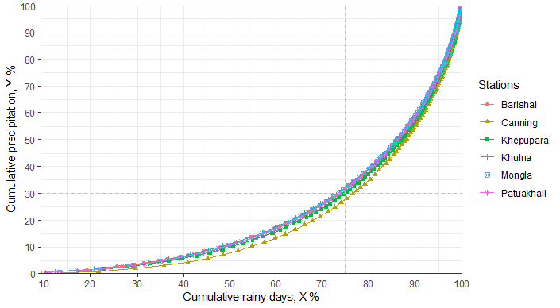

***Fig. 2.*** *Concentration curves of cumulative rainfall in the coastal zones* (TNR, 10 pt)

Table 3. Observatories in coastal zone in Bangladesh and West Bengal (TNR, 10 pt, single spacing)

|  |  |  |  |  |  |  |
| --- | --- | --- | --- | --- | --- | --- |
| Observatories | Canning | Khulna | Mongla | Barishal | Patuakhali | Khepupara |
| Latitude (N) | 22o18' | 22o47’ | 22o28’ | 22o43’ | 22o20’ | 21o50’ |
| Longitude (E) | 88o40' | 89o34’ | 89o36’ | 90o22’ | 90o20’ | 90o41’ |
| Elevation (m) | 3.5 | 2.1 | 1.8 | 2.1 | 1.5 | 1.8 |
| Data Start | 1966 | 1974 | 1991 | 1949 | 1973 | 1974 |
| Data End | 2017 | 2017 | 2017 | 2017 | 2017 | 2017 |

# CONCLUSIONS (headlines: TNR Bold, 12 pt) – Should not exceed 100 words

Conclusions should include the generalisations inferred from the results, theoretical and/or practical implications of the work and recommendations.

# ACKNOWLEDGEMENT (headlines: TNR Bold, 12 pt) – Should not exceed 50 words

The authors would like to acknowledge the support and funding received from the sponsors (Project Number if any).

**Units**

Use SI (MKS) as primary units. In expressing doses of nitrogen, phosphorus and potassic fertilizers, those should be in the form of N, P, K, respectively and be expressed in terms of kg ha-1 for field experiments and mg kg-1 for pot culture studies. Yield of crops should be reported in t ha-1.

**Subheadings (TNR 12 pt bold left aligned)**

# REFERENCES (headlines: TNR Bold, 12 pt, single spacing)

# (Not more than 5 references)

References should be listed arranged in alphabetical order beginning with the author’s names and initials, followed by the year of publication, title of the article, title of periodical, volume, issue and page. Example:

Pani, D.R., Sarangi, S.K., Misra, R.C., Pradhan, S.K., Subudhi, H.N. and Mandal, T.K. (2013). Performance of rice germplasm (*Oryza sativa* L.) under coastal saline conditions. *Journal of the Indian Society of Coastal Agricultural Research* **31**(1): 11-20.

Please refer to Author guidelines in the download section of the symposium website for reference styles of books, book chapters, bulletins, thesis, etc.

In the text, references should be cited with the name of the author(s) with the year of publication in parenthesis, e.g., Dutt and Polara (2004), Panigrahi *et al*. (2006).